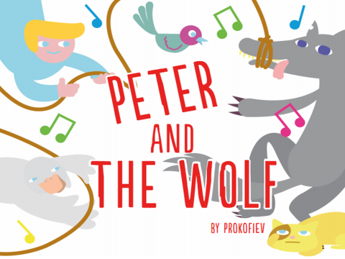

P.S. 215 Morris H. Weiss

Principal: Antonella Bove

Assistant Principal: Ellen Resnick

Students attending BBT after school program.

BRIGHTON BALLET THEATER (BBT) THE SCHOOL OF RUSSIAN BALLET

Executive Director: Irina Roizin

Costume Designer: Tanya Lugovska

Dance Teacher and Choreographer: Ana Lejava

Guest Teacher: Irina Lapteva

**Guest Performers: Emma Shnayderman , Nellie Podokshik, Daniella Zavadski and Karina Shilonsky**

**THIS PROGRAM IS SUPPORTED with the**

**PUBLIC FUNDS FROM THE NEW YORK CITY DEPARTMENT OF CULTURAL AFFAIRS IN PARTNERSHIP WITH THE CITY COUNCIL**.

Produced by

**Ana Lejava and Irina Lapteva**

**Brighton Ballet Theater**©Brooklyn, NY 2016

## **Choreography by**

## Ana Lejava

## **Produced by**

## Ana Lejava and Irina Lapteva

# ***Brighton Ballet Theater***

## **June 16th, 6:00 pm** at PS215 Auditorium

415 Avenue S  
Brooklyn, NY 11223

# Dance Presentation

## Brighton Ballet Theater

## & PS215 The Morris H. Weiss

## Elementary School presents

Musical instruments

Special Thanks



**PROGRAM**

rogram

Music program inside art

Musical instruments

**Prokofiev & his story**

*Peter and the Wolf is a piece of orchestral music written by Sergei Prokofiev. This piece contains a children’s story and as the narrator speaks, the orchestra accompanies them. The composer uses a different instrument and melodic motif for each character. This type of music is called programme music because the music specifically represents the characters and is used to make the story come to life. Prokofiev used instruments from four instrument families to tell his musical story. The four instrument families are: strings, woodwinds, brass and percussion. Discover in this story which instrument represents the main characters: Peter, the cat, the bird, the duck, the wolf, Grandpa and the hunters.*

**About the Composer**

***Sergei Prokofiev*** *(born April 23, 1891, Sontsovka, Ukraine, Russian Empire—died March 5, 1953, Moscow, Russia, U.S.S.R.) was 20th-century Russian (and Soviet) composer who wrote in a wide range of musical genres, including symphonies, concerti, film music, operas, ballets, and program pieces. He wrote his first piece of music at age 5 and went on to study music at St. Petersburg Conservatoire, where he was taught by some of the best Russian composers of the time, such as Nicolai Rimsky-Korsakov. Some of Prokofiev’s famous works include the ballets “Romeo and Juliet” and “Cinderella.” He is considered to be one of the most important composers of the twentieth century.*

**Synopsis:** Peter lives in the country with his grandfather. His grandfather tells Peter not to play in the meadow, because a wolf lives in the forest, but Peter does not listen. He leaves the gate open and goes into a green meadow. Little ducklings follow Peter, when the see that gate is open. In the meadow Peter meets and plays with the birds, cat, butterfly and little ducklings. The wolf comes out of the forest into the meadow and eats the duck. Peter is brave and, with the help of the cat and birds, he catches the wolf. Hunters help him put the wolf into a cage and take him to the zoo. Grandfather is very surprised when he sees what Peter has done.

**Cast: *Students of PS215 attending BBT after school program:***

*Peter and his friend: Britanny Liang & Anna Vagele*

*Wolf - Elizabeth Strakovsky*

*Birds - Sofia Mdahe, Sheen Lola Heady,*

*Alexia E. Matskevich, Felicia Chan,*

*Elizabeth Razpopova, Jing Hueng*

*Ducklings - Vivian Lin, Leyla Laruiocco Heady*

*Butterfly - Farangiz Majitova*

*Cat - Gabriela Gonzalez*

*Hunters - Emily Portuov*

*Isabella Goicoechea*

*Lorie Sobieszczuk,*

*Sherlyn Hernandez,*

*Grandmother - L.A. Ruocco Heady*

Musical instrumentsMusical instruments

Russian Dance from Ballet “The Nutcracker”:

Teacher & Choreographer – Edouard Kouchnarev

Performed by the student of BBT’s Division of Staten Island: **Karina Shilonsky**

Circus

Teacher & Choreographer – Edouard Kouchnarev

Performed by the student of BBT’s Ballet 5-A: **Daniella Zavadski**

Heart Cry   
Teacher & Choreographer – Ana Lejava

Danced by the student of BBT’s Ballet 4-A: **Emma Shnayderman**

Fairy Doll Variation

Teacher & Choreographer – Edouard Kouchnarev

Performed by the student of BBT’s Ballet 5-A: **Nellie Podokshik**

Guest Performances